Homework day 1

**Repetition of concepts**

Have a look at the material that I uploaded for day 1. If you have time, you will benefit from watching the lecture on EGT from Yale courses. With the help of these materials, as well as with my lecture notes, explain the following concepts in your own words

* 2-player game
* Strategy
* Payoff-matrix
* Prisoners Dilemma (PD)
* Stag hunt game
* Hawk Dove game
* Best response
* Nash Equilibrium
* Difference between evolutionary and normal game theory
* Evolutionarily stable strategy (ESS)
* Price equation
* Why would we think that cooperation is not an ESS in the PD

**Modelling with NetLogo**

1. Go to the model „ants“ in the biology section of the model library. Read through the info to understand what the model is doing. Try out the model and change a few parameters. Then, discuss with your partner which parameter would be the most important to vary when analyzing “sum [food] of patches” as an output of the model. Use the behavior space to vary this parameter, and make a plot of “sum [food] of patches” (see below) with a graphic program of your choice.

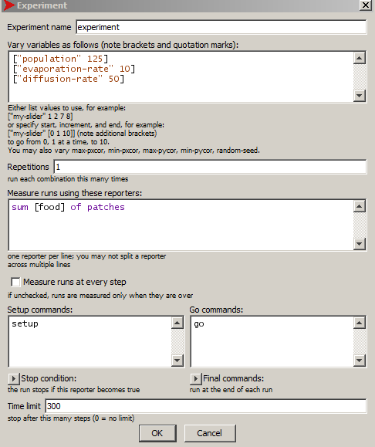

1. Look at the model “cooperation” in the social science section of the model library. Read through the info and run the model.
   1. What game is modelled here?
   2. Can you explain the short-term and long-term behavior of the population sizes of the “greedy” and “cooperative” cows?
   3. Read on the internet about the “tragedy of the commons”. Could we argue that the behavior of the cows is similar to humans using fish in a lake, or humans using rangeland for their livestock?